Xiaoting Lian

CISC 3140

Lab 6

Task 1 was easy that I created both Repo1 and RepoMeta on github and I clone the repository to my desktop to work with it as a copy of the file. It took me some time to find out “nano HelloWorld.java” can edit the file in the command line rather than edit the file directly, therefor I changed the “hello, world” to “hi, world”. And save the change

For task 2, it is really difficult that I have to read so much. And I end to downloading TortoiseSVN, I create a Repository in my own machine and export it to github

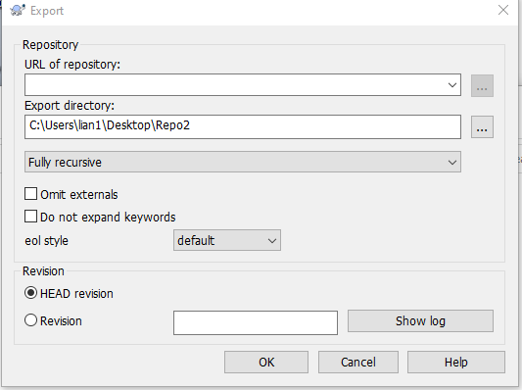

The this tool, every time I make change to I was be able to export and import all the file in the repository.

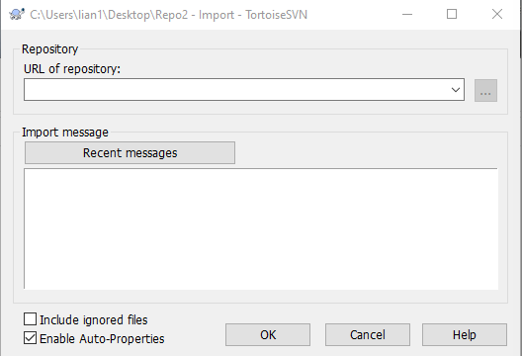

I understand that Decentralized VCS is more flexible than Centralized VCS, but in this assignment, since I have the tool to make change without using terminal commands, it is much easier to do task 2.